**Final Assessment outputScreenShots**

**Final Assessment Devops(Maven,Junit, Git,Sonarqube,Docker,Jenkins) implementation for Microservice Customer Producer application**

1. Push the code through IDE (STS or Eclipse) into github remote repository backend

**URL=** [**https://github.com/abkhuddus/Finalproducer.git**](https://github.com/abkhuddus/Finalproducer.git)

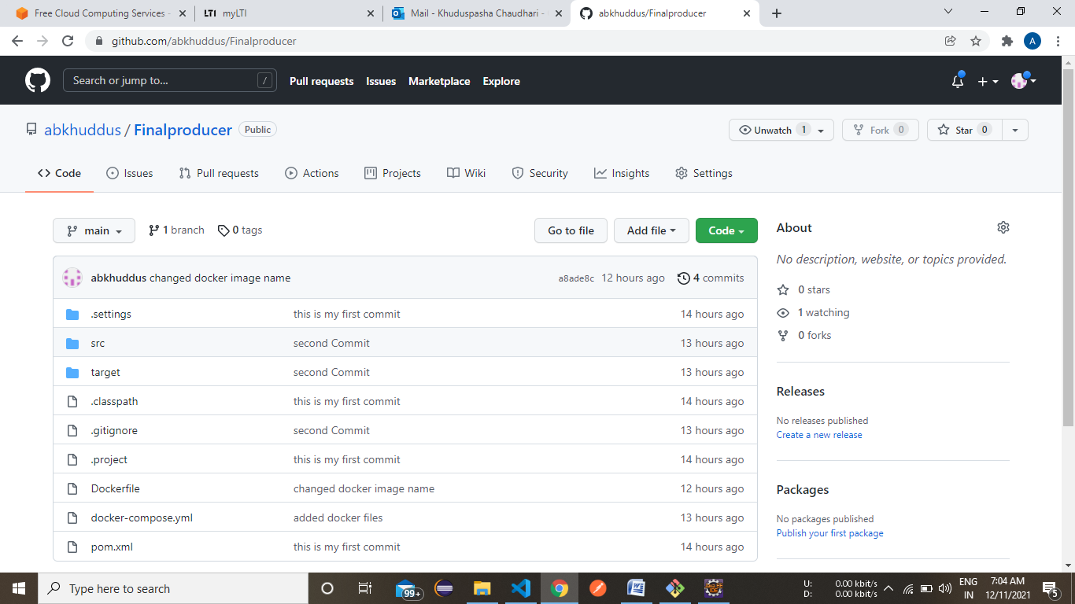

**2** Push Frontend code also into git command line

URL=https://github.com/abkhuddus/FrontEndAngular

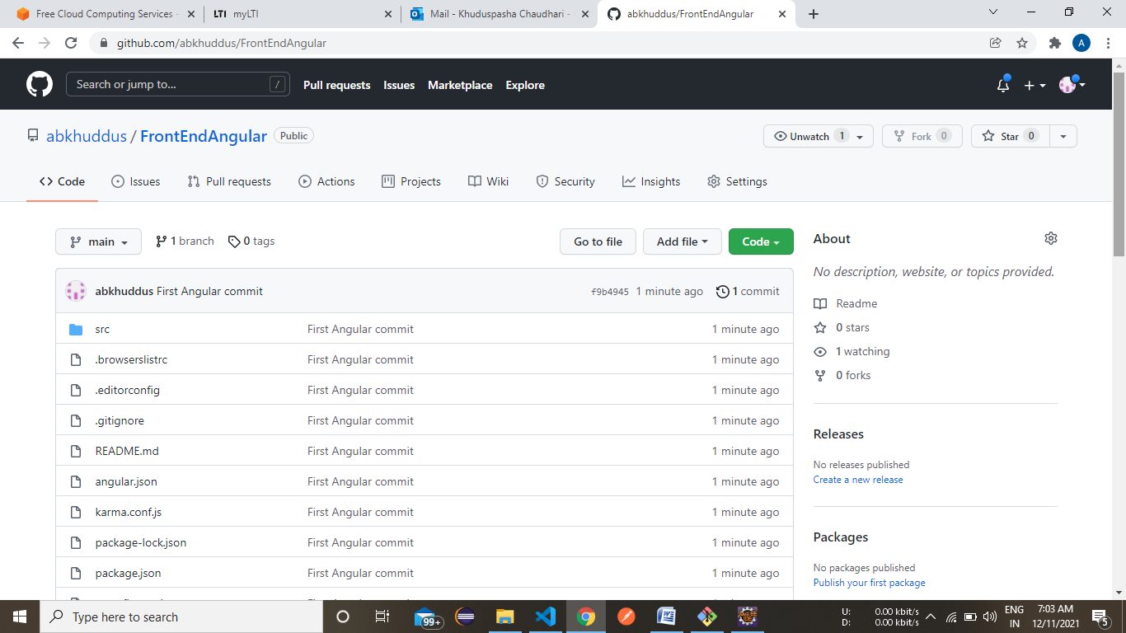

3 Run the possible number of Junit test case

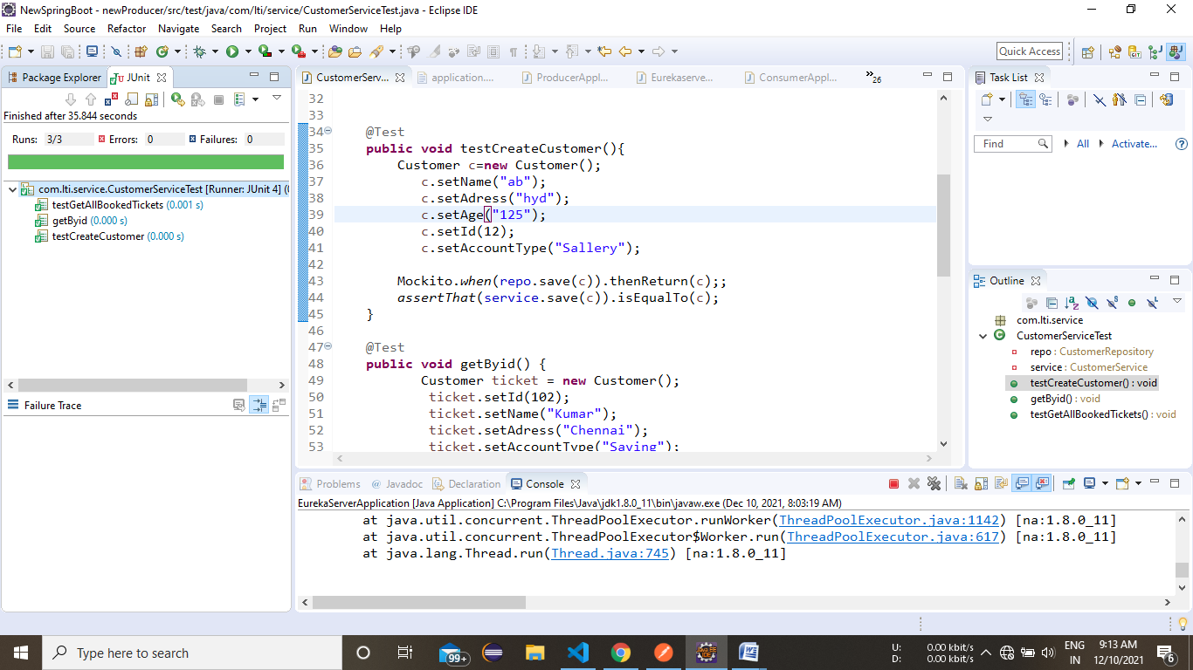

4. Jacoco test coverage in STS - screenshots required optional

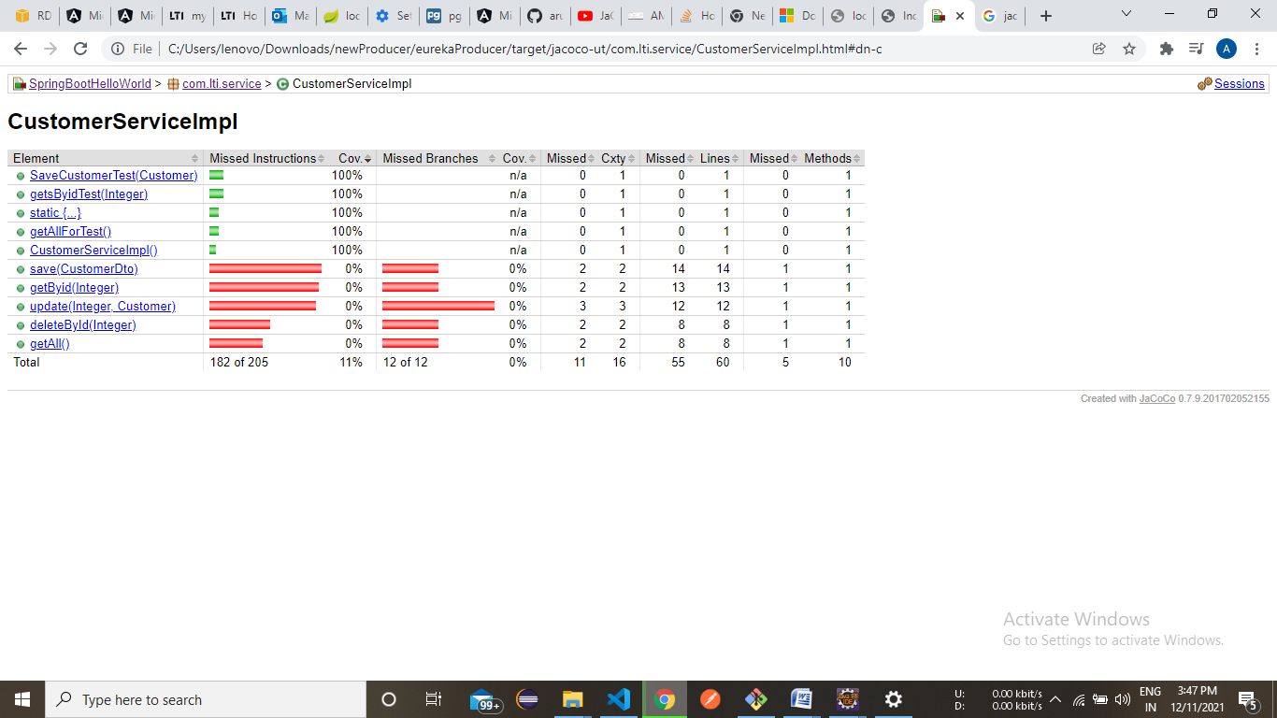

**Devops**

5. Loggers( Log4j ) and be implemented for all the backend java classes

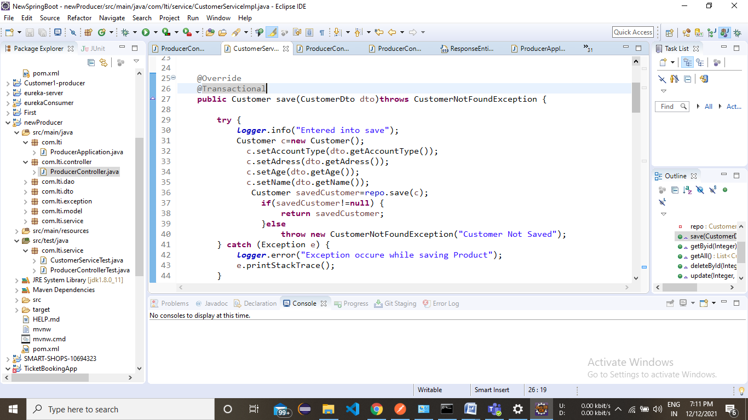

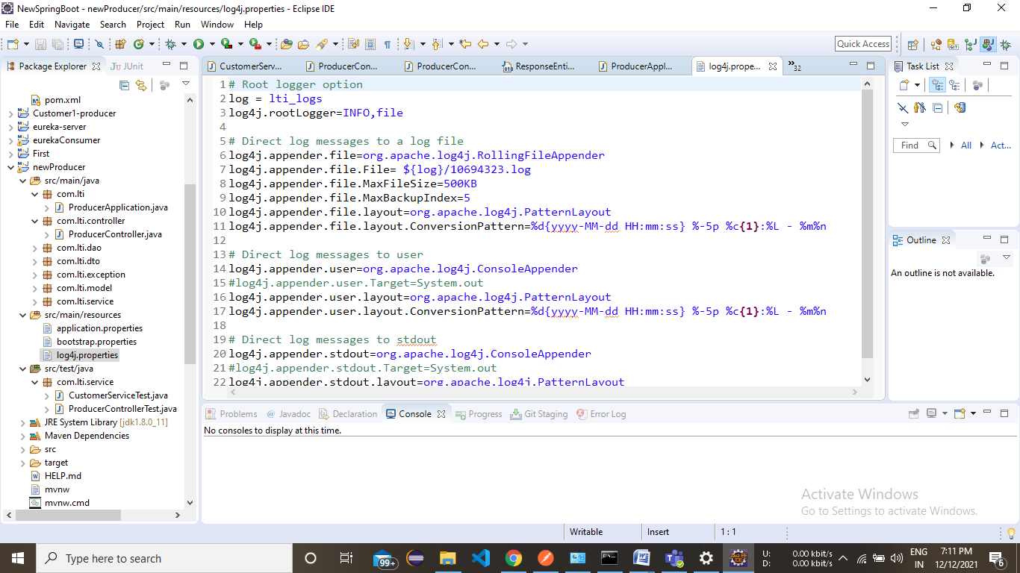

6 Debugging can be done with screenshot

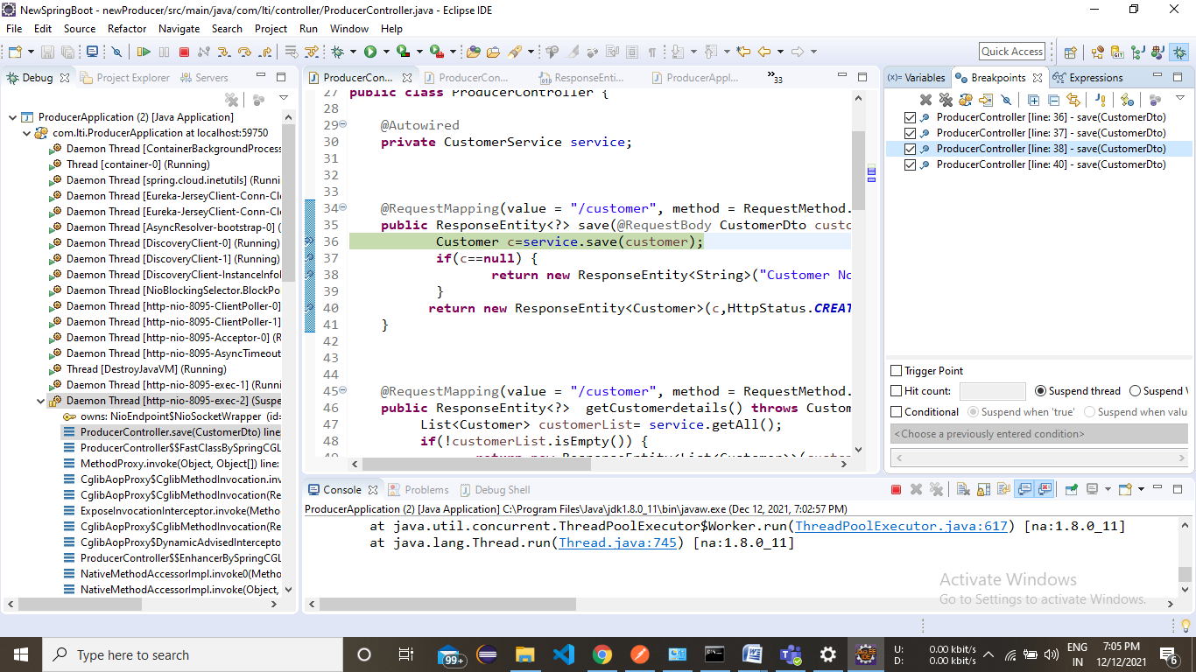

**7 Code quality can be checked for backend code- SonlarLint**

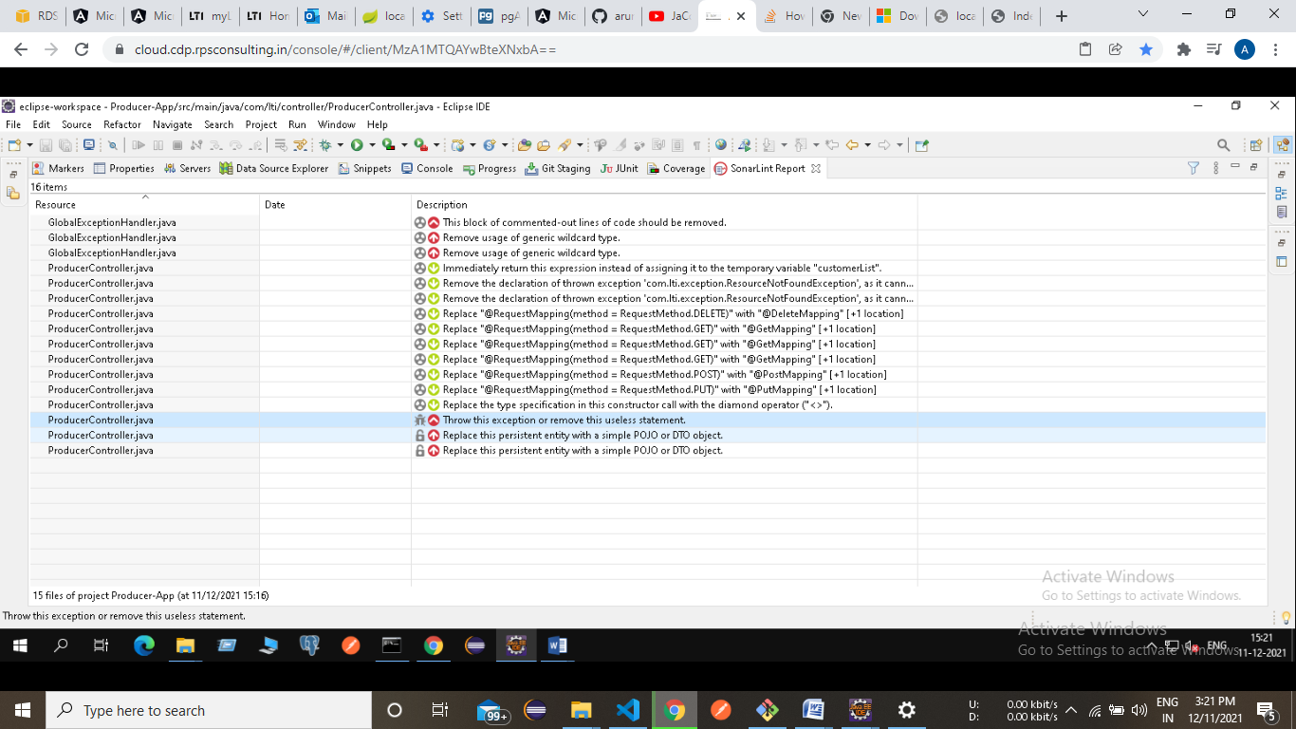

8 Project can be imported in Sonarqube for bugs and vulnerabilities

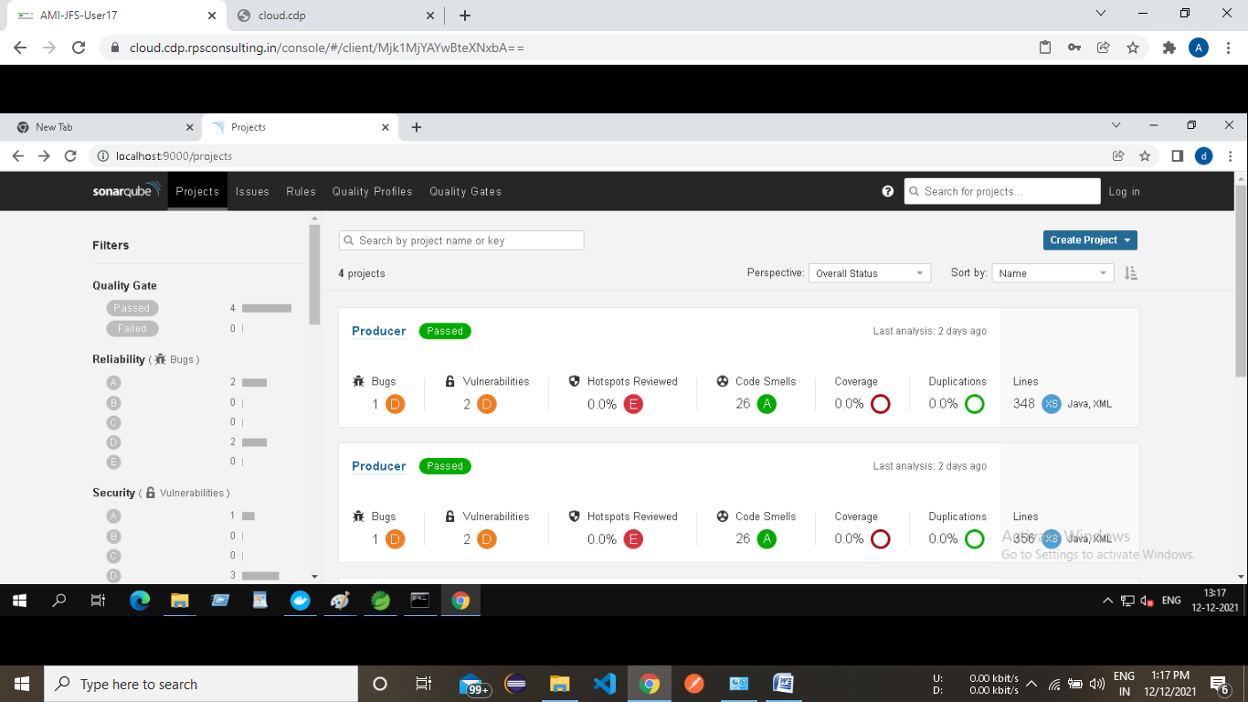

9 Create Maven build-mvn clean install

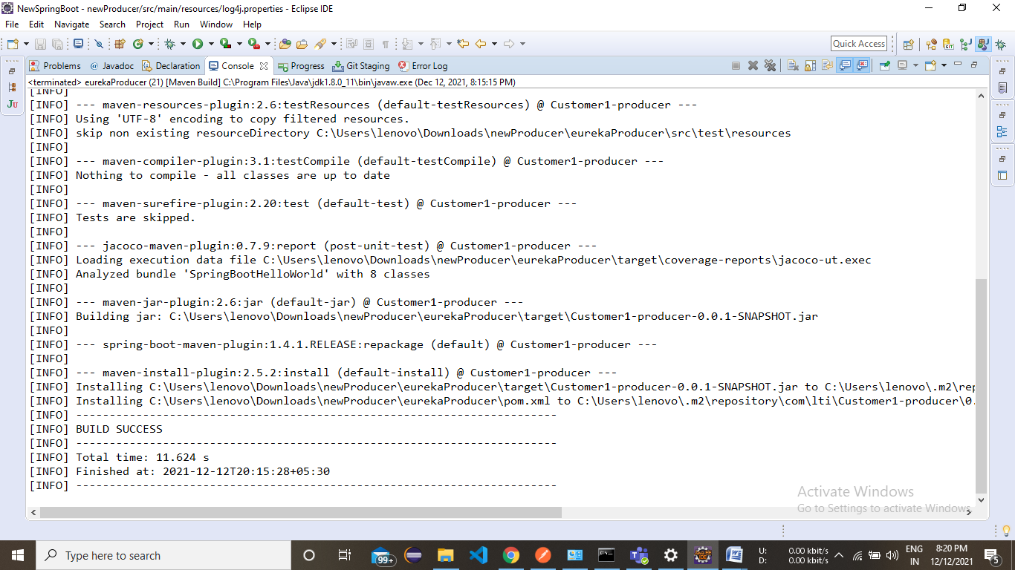

10 Docker image and container creation and deployment in Dockerhub

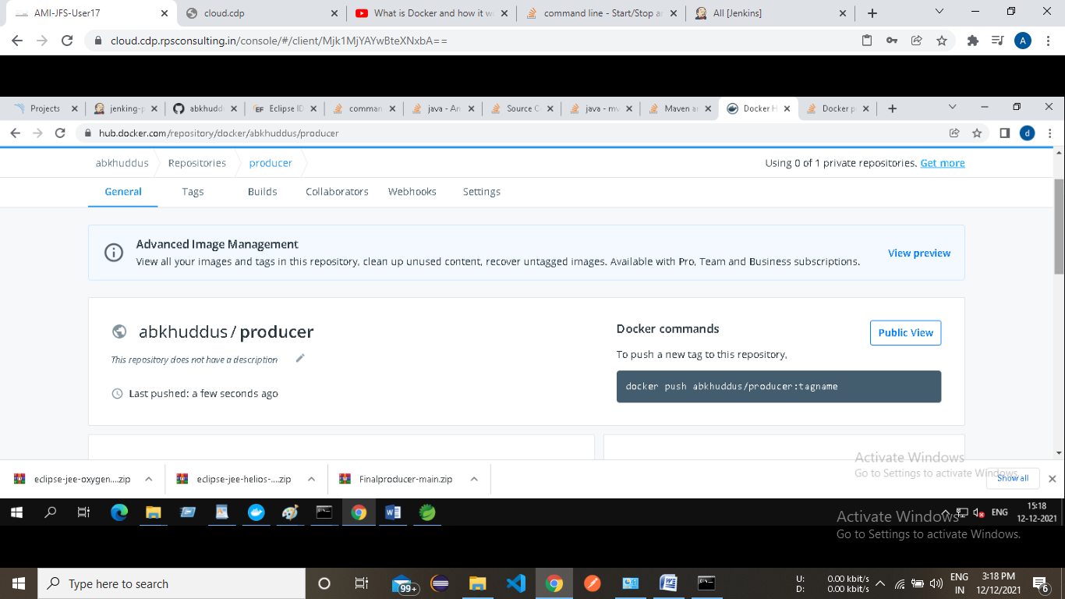

**11** Jenkins code pipeline can be created with minimum 3 stages

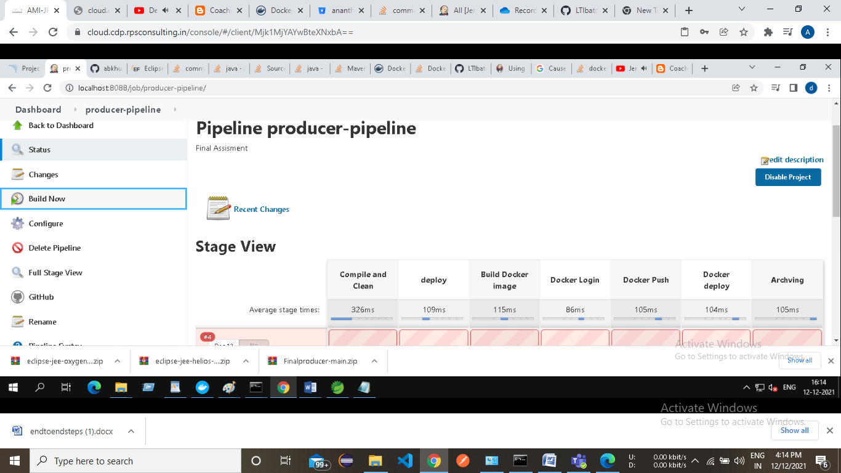

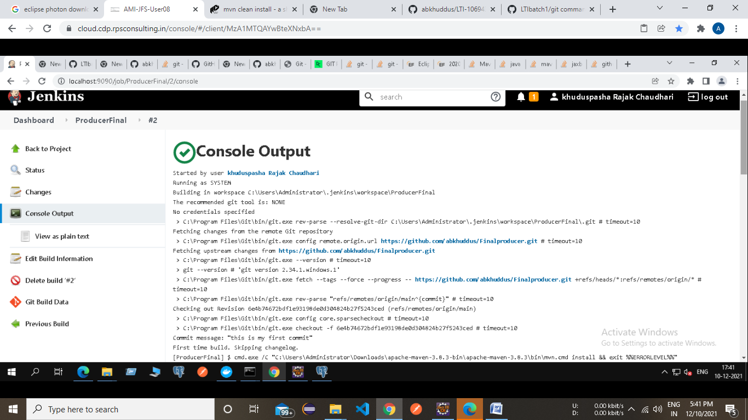

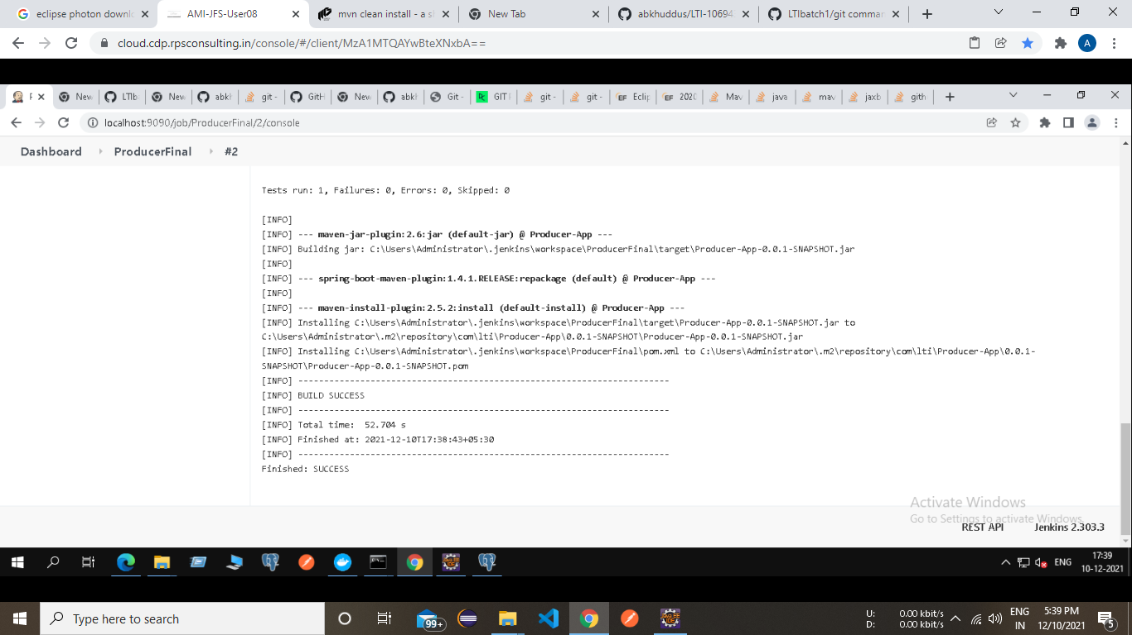

12 Use S3 bucket to deploy Frontendcode

URL= <http://angular-final.s3-website.ap-south-1.amazonaws.com>

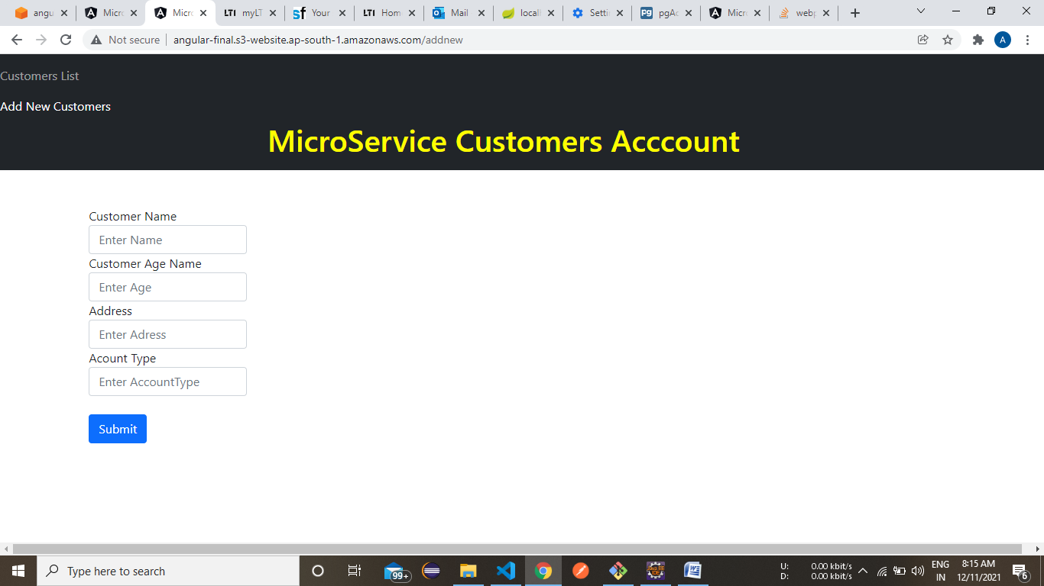

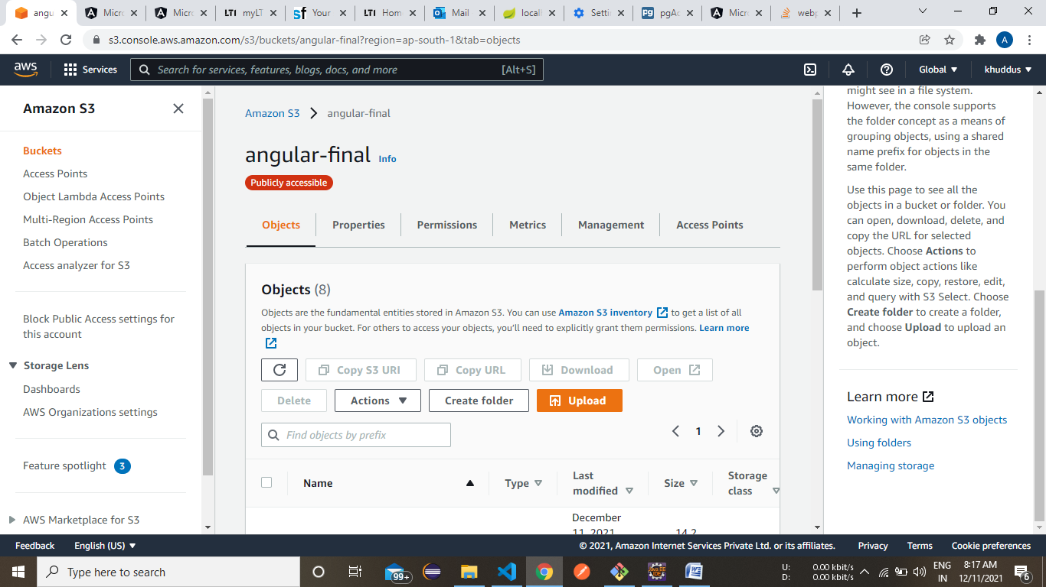

13 Use RDS instance to connect to PostgreSQL instance

URL= test-postgres.c1y6th6yinky.ap-south- 1.rds.amazonaws.com

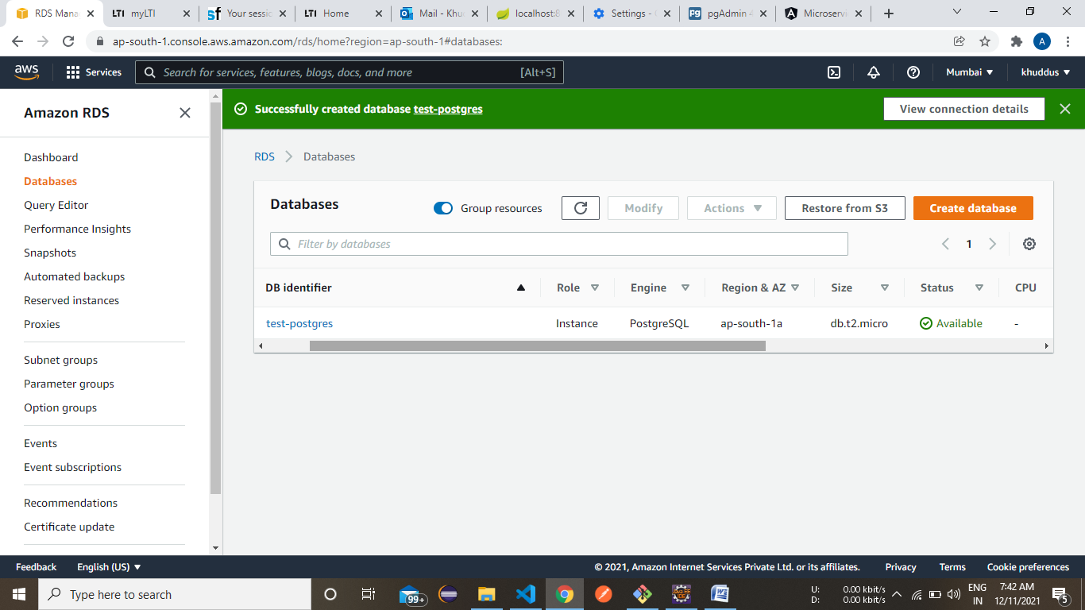

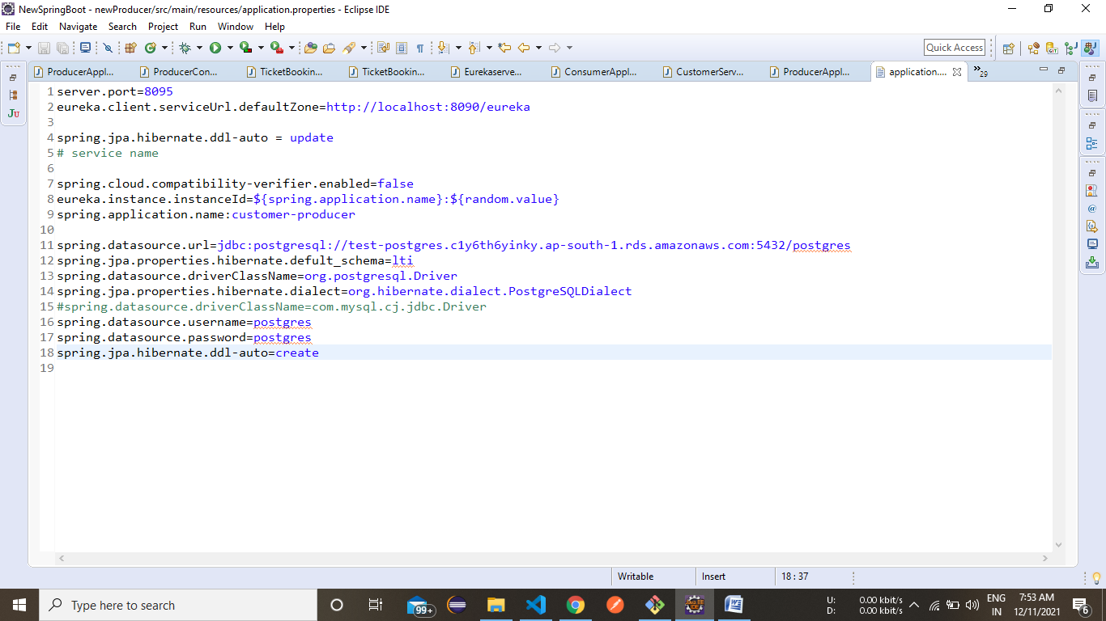

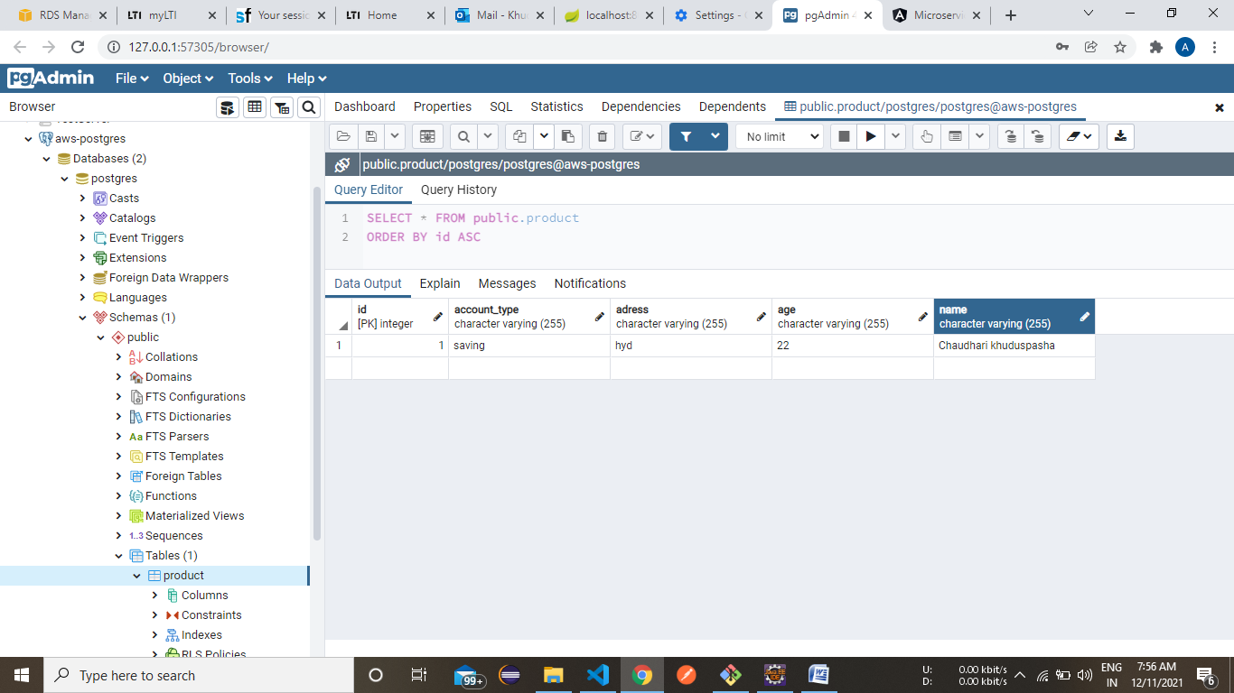

Spring Microservices Angular Result

1.HomePage

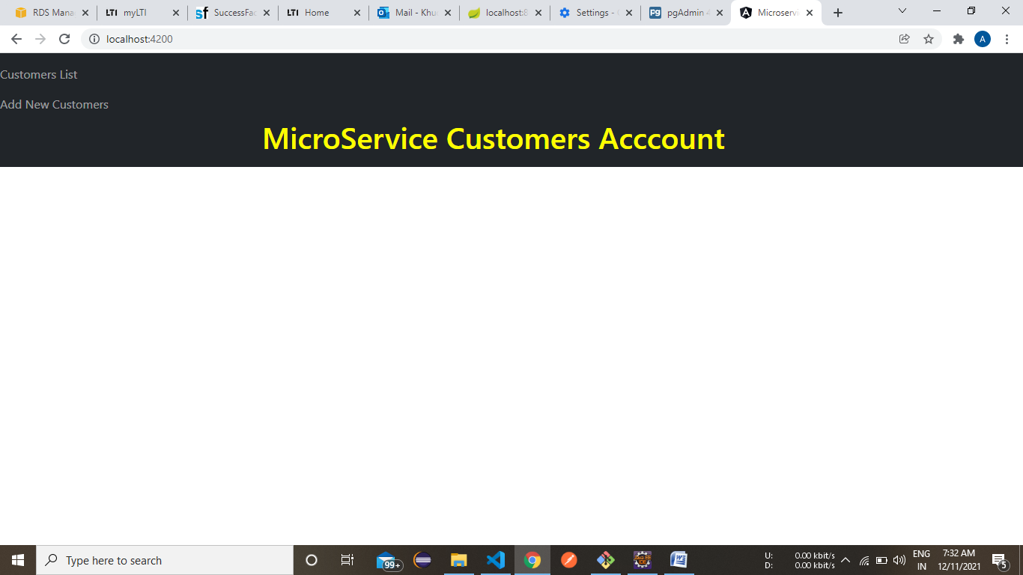

2.CustomerList

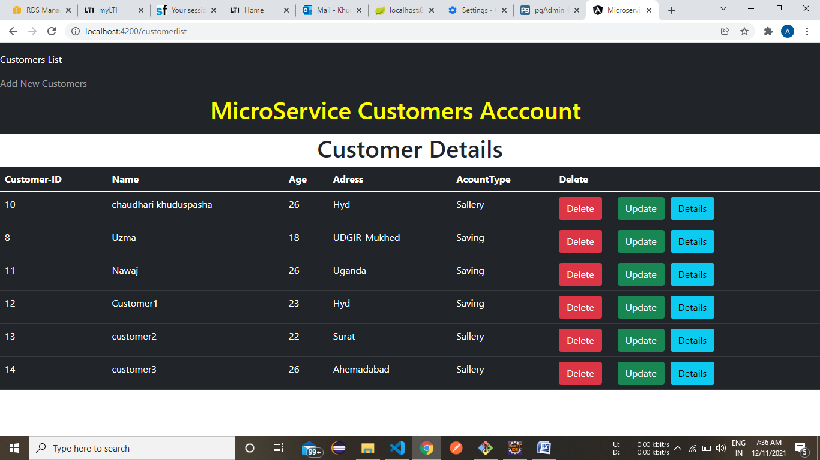

3. Customer Details

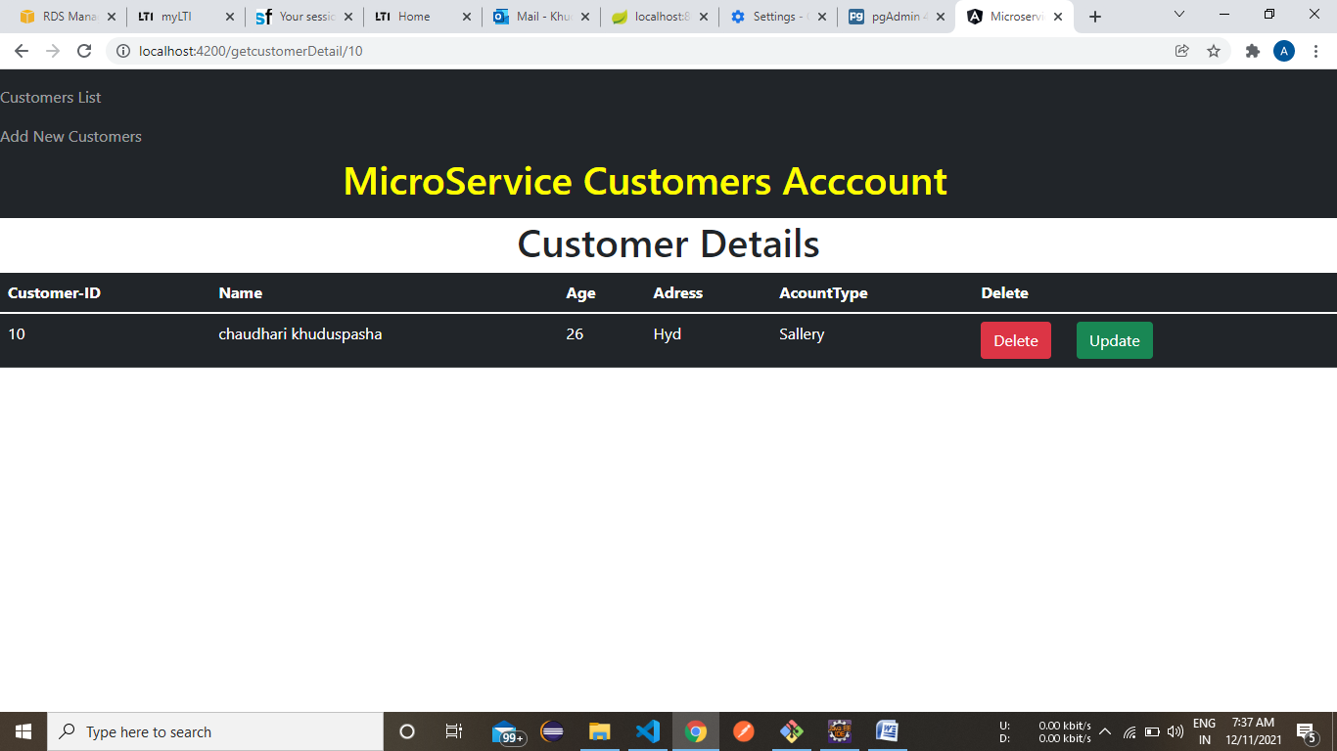

**4. Update**

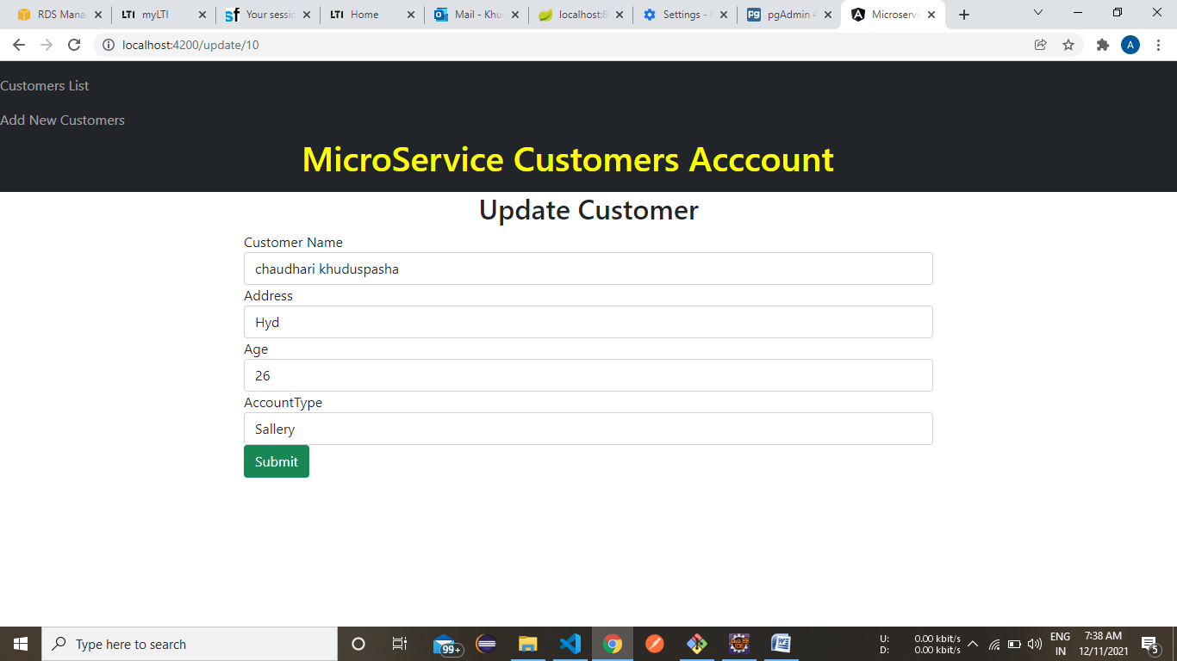

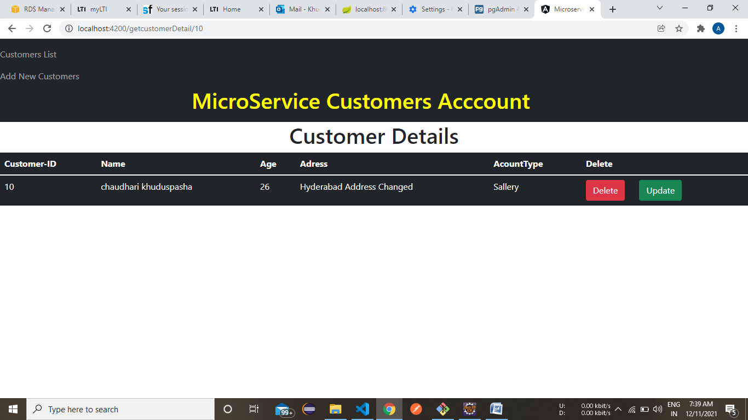

4. Delete

